Music By:

Old News Band

Set-Ups Provided

$25 Per Person

BYOB

For Tickets call 610-793-9817

E-Mail: [amway.steven@gmail.com](mailto:amway.steven@gmail.com)

No tickets will be sold at the door

***Fame Fire Co.***

***Beef and Beer***

***Capital Fund Raising Benefit***

***Friday September 5th***

***Doors Open @ 7P.M.***

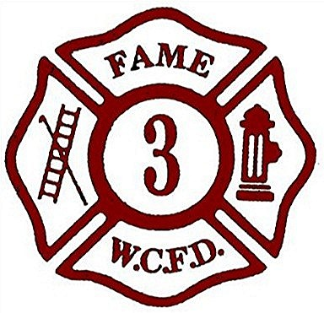

***Where: The Silsby Room***

200 E. Rosedale Ave

(E. Rosedale Ave & S. Matlack Sts.)

West Chester, PA

